Northport hosts annual tree seedling giveaway to promote conservation and recycling
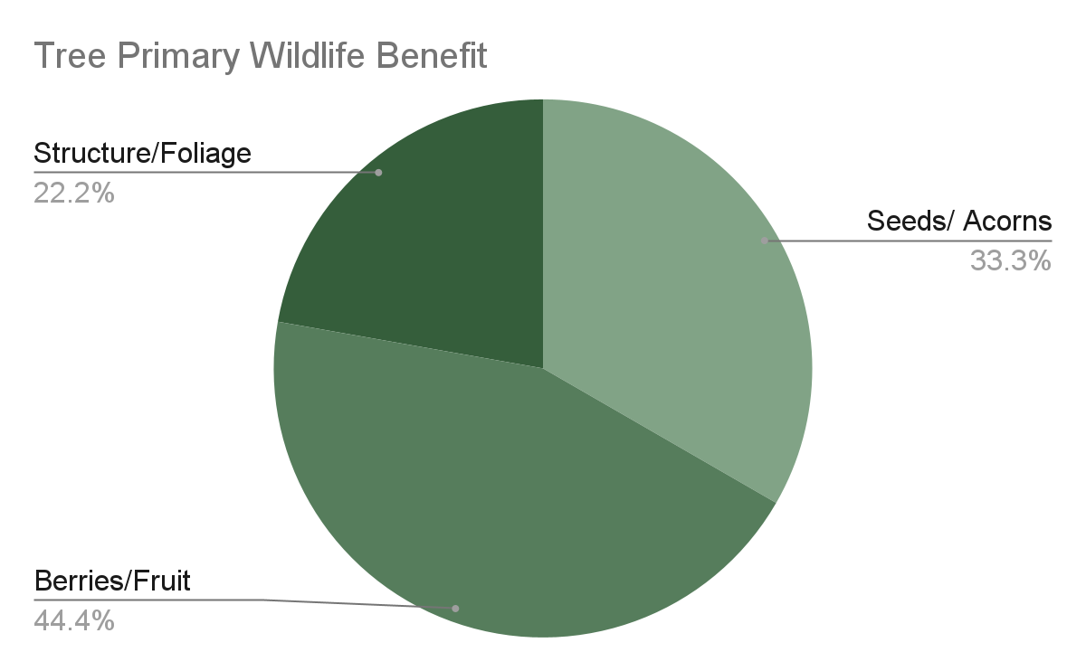
By Joanna House
NORTHPORT, Ala. — The city of Northport hosted its third annual tree seedling giveaway Saturday, Feb. 28, offering residents free trees while promoting environmental conservation and the city’s recycling program.
The event began at 7 a.m. and continued until supplies ran out. It was held in partnership with the Alabama Forestry Commission and Alabama Power.
Nine tree species were available, eight of which are native to Alabama. The seedlings were purchased using $1,000 donated by Alabama Power along with support from the Alabama Forestry Commission.
Residents from across the area attended the event, with some arriving well before it began. Whitney DuBose, Northport community relations coordinator, said a line of people formed more than 30 minutes before the doors opened.
“The Forestry Commission is having their seedling giveaway the same day we’re having ours, but it has not seemed to affect our turnout,” DuBose said.
Many attendees planned to use the trees to support wildlife habitats. Roy Davis, a firefighter with the Alabama Forestry Commission, said the seedlings are often planted for conservation and hunting purposes.
“A lot of people come and get trees and plant them for things like turkeys and wildlife and stuff like that,” Davis said.
Tuscaloosa County resident Jose Moran traveled from outside Northport city limits to attend the event and collect trees he plans to plant at his home.
Northport Recycling also attended the event to encourage residents to sign up for the city’s recycling program. Quinton German, the recycling superintendent, said the event has helped increase participation in the past.
“We’ve had up to 20 people sign up at these events,” German said.
The annual giveaway provides residents with native trees while also giving city officials an opportunity to connect with the community about conservation efforts and recycling services.

